  **ALAGAPPA COLLEGE OF TECHNOLOGY**

**ANNA UNIVERSITY-600025**

Project type:

Website designing: Building a Website: To Create your first website using WIX/Canva.

Project name:

Jass Roasters. Inc

Department:

B.Tech-Pharmaceutical technology

Team Details:

|  |  |  |
| --- | --- | --- |
| Name | Registration number | Naan mudhalvan Id |
| SHARAFATH HUSSAIN J | 2020308031 | 7C38C60349803F1BC0E4D5A6D93F5CC1 |
| SARA NASRIN S | 2020308030 | 575475198F09D6283244C4C76CC7C8FA |
| NIKITA RAJAKUMAR | 2020308026 | 7EECC0CF6CEE85DA0EB4880D14C571A4 |
| NEHASRI S R | 2020308025 | CEB82A0395F1B0DB9FF4AE00B6D35FE3 |
| NAKULAN A | 2020308024 | F45454ECDAC91C78D984E83DB30A9C34 |

--------------------------------------------------------------

Brand Name: Jass Roasters.Inc

Category: Coffee roasters and cafe

Target Audience: People

Email : [sharashareff21@gmail.com](mailto:sharashareff21@gmail.com)

Website URL :

https://sharashareff21.wixsite.com/jass-roasters-inc

File Upload - Website URL , video explaining the process.

Document - with Attached Screenshots with Steps

PPT with details explaining the process of creating an advantageous website using wix.com

**Step by-step guide for creating a website using Wix.com:**

1. Sign up for a Wix.com account.

2. Choose a website template.

3. Customize the website's design and layout.

4. Add content, including text, images, and videos.

5. Optimize for mobile and search engines.

6. Connect a custom domain.

7. Set up ecommerce features (if applicable)

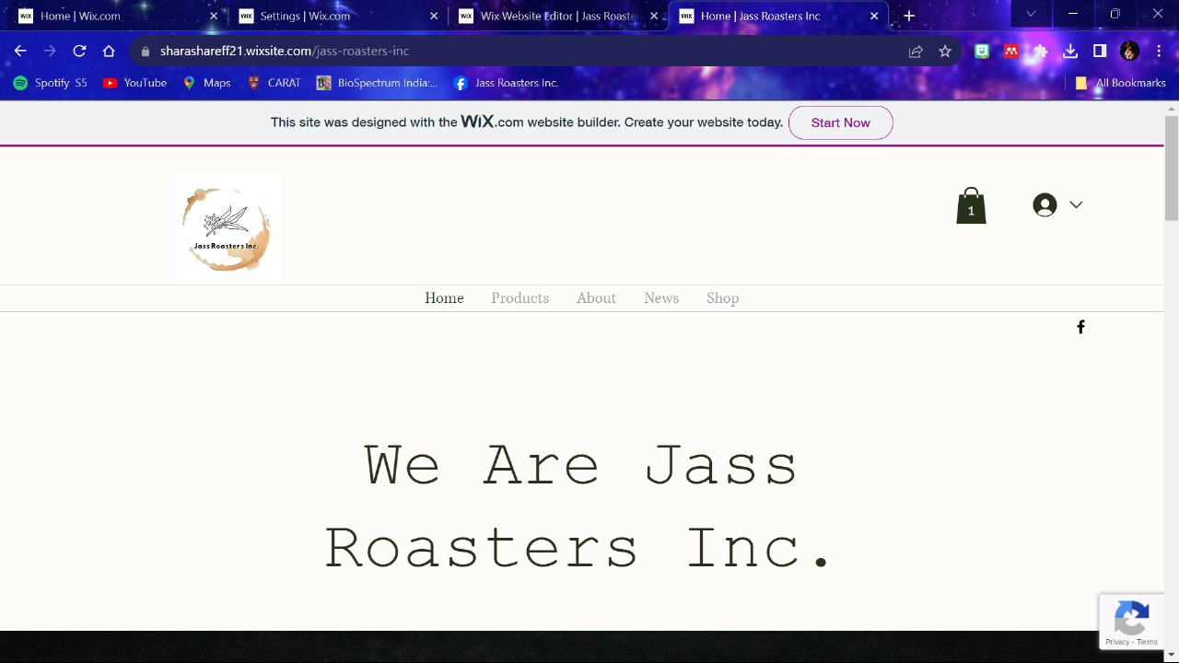

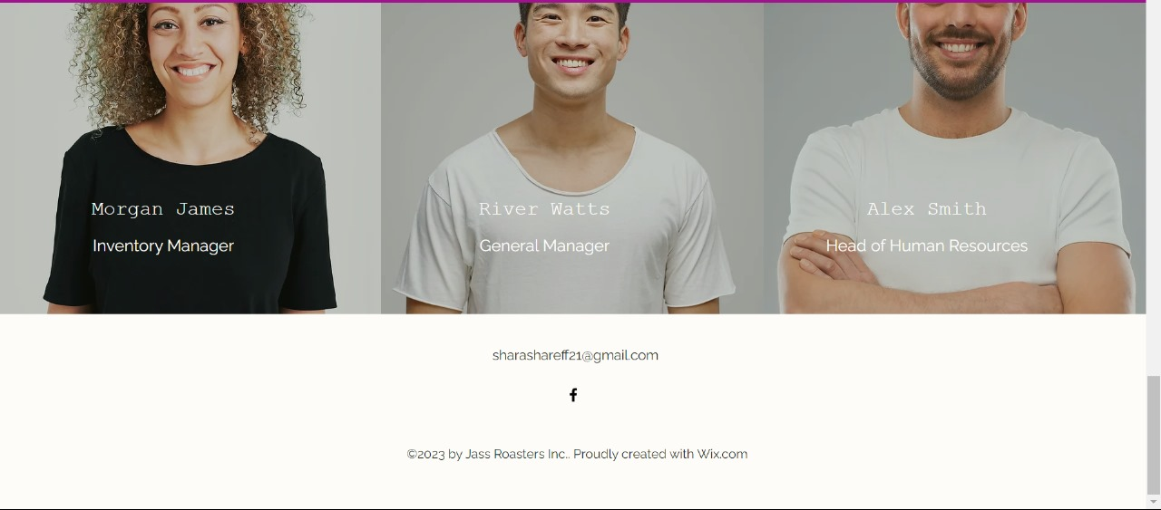

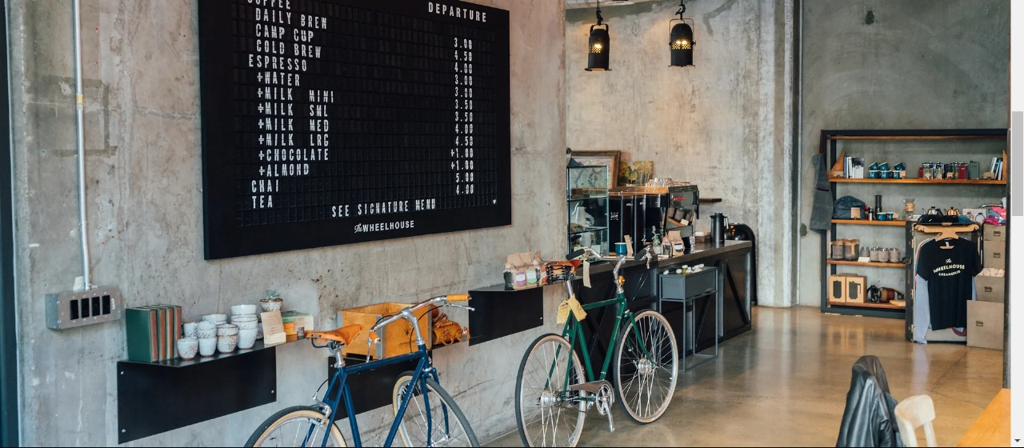

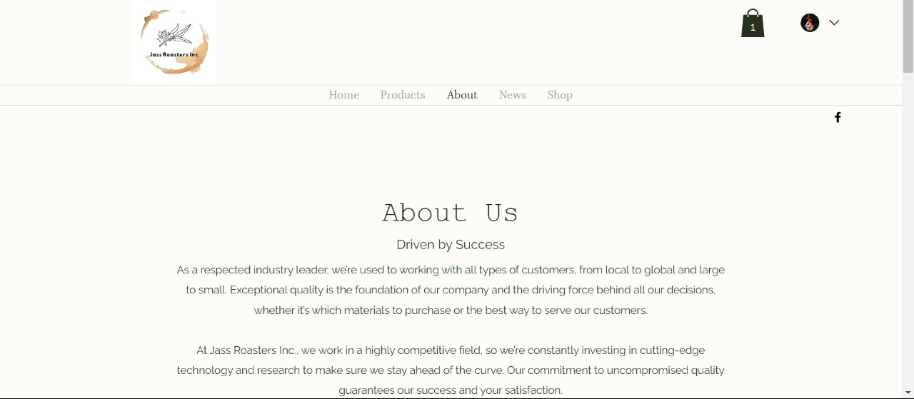

Highlight the benefits of having a website for Jass Roasters Inc.:

* Increased online visibility
* 24/7 accessibility for customers
* Showcasing products and services
* Building credibility and trust
* Expanding market reach
* Easy customer communication

Disadvantages of Creating a Website:

* Initial time and effort required
* Maintenance and updates
* Competition in the online space
* Technical issues and security concerns